1. A. for the decimal part, 15=0000 1111=1111

for the fraction part:

0.625=0.b4b5…b

1.25=b4.b5…b

B4=1;

0.25=0.b5b6…b

0.5=b5.b6…b

B5=0;

1=b6.b7…b

B6=1;

B7…b=0

So 0.625=0.101

So 15.625=1111.101=1.111101\*2^3

E=3, Exponent=3+127=130

So -15.625=1 1000 0010 1111 0100 0000 0000 0000 000

It can be represented exactly

b. 1/6

1/6=0.b1b2…b

1/3=b1.b2…b

B1=0;

2/3=b2.b3…b

B2=0;

4/3=b3.b4…b

B3=1;

1/3=0.b4…b

.

.

.

1/6=0.0010 1010 1010 1010 1010 1010 10=1.0101 0101 0101 0101 0101 010\*2^(-3)

E=-3, Exponent=-3+127=124=0111 1100

1/6=0 0111 1100 0101 0101 0101 0101 0101 010

Cannot be represented exactly

1. A. 0x0D000000= 0 0001 1010 0000 0000 0000 0000 0000 000

Exponent=26

E=Exponent-bias=26-127= -101

Fraction=0

So the result is 1.0\*2^(-101) =0.000 000 000 000 000 000 000 000 000 000 394 430 45

b. 0xC4650000=1 1000 1000 1100 1010 0000 0000 0000 000

Exponent=136

E=Exponent-Bias=136-127=9

decimal part: 2^(-1)+2^(-2)+2^(-5)+2^(-7)=0.7890625

So the decimal number should be 1.7890625\*2^9

1. .text:

LDR R0, =X

MOV R2, R0

MOV R3, =0x7f800000

AND R2, R2, R3

ADD R2, #0, [R2, LSL #4]

MOV R3, =0X807FFFFF

AND R0, R0, R3

ADD R0, R0, R2

.data:

X= …

1. 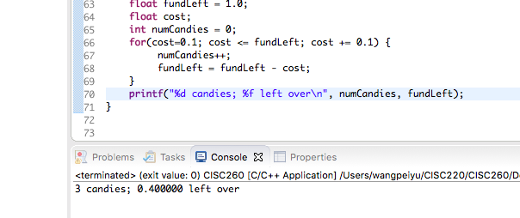

Results is 3 candies and 0.400000 left over

The right results should be 4 candies and 0 left over

Therefore, the result is not what is expected

Because 0.1 is irrational when being converted into single-precision number, therefore it will lose precision

But I think I can multiply fundLeft/cost/cost-increase by 10 at the same time so that it will give the right solution (just to avoid 0.1 because 0.1 isn’t rational)

Result:

